RedHat 6.2
Kernel & Shell
- Linux is operation system.
- Linux system is described as kernel & shell
- Kernel is a main program of linux system. It controls hardwares, CPU, memory, hard disk, network card etc...
- Shell is an interface between user and kernel. Shell interprets your input as commands and pass them to kernel.
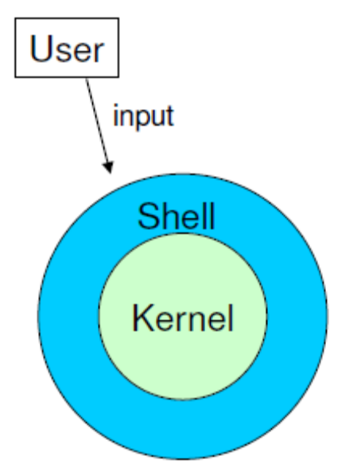
- The shell and the window environment are programs.
- Programs only access to hardware is via the kernel. Linux default shell is BASH (Bourne Again Shell).
- Many people can use one machine at the sametime.
- Data, directory, process, harddisk etc (almost everything) are expressed as a file.
- Process is running program identified by a unique id (PID).
Directory Structure -
- /bin - This contains files that are normal users command. These are available for use by all users.
- /mnt - Provides a location for mounting devices,such as remote filesystems and removable media
- /home - This is where user home directories are stored. We can create 65000 users in home directory. All users are save under home directory. Eg - /home/username
- /var – All system related logs are stored in var directory. Sys Admin needs to check the logs every day. var/tmp – Temp file has store 21 days then it will be delete automatically.
- /etc - Various system configuration files are stored here.
- /dev – All hardware related files are stored in dev. E.g. harddisk, CDROM drive, etc.
- /root - This is the root (administrator) user's home directory.
- /sbin – Admin users command. Binaries which are only expected to be used by the super user.
- /tmp - Temporary files. Temp files are stored only 10 days then it will delete automatically.
- /boot - Has the bootable Linux kernel and boot loader configuration files (GRUB). All booting relating files and kernel files are locating in boot directory.
- /usr - Contains user documentation, games, graphical files, libraries (lib), etc...
- /lib – All system related modules are stored in /lib.
- /proc – All current information stored in this directory. It likes a “Task Manager” in windows OS. We can check the system current information.
- /selinux – Security linux. It likes a firewall and its highly secure not use in India. It is using in US Army.
Files are put in a directory.
All directories are in a hierarchical structure.
User can create and delete any directories.
Top directory is / (Slash) or Root.

Some Simple Commands
Command Line Syntax
Command <options> argument

Basic Utilities

man – Type man followed by a command (for which you want help) and start reading.
Press q to quit the manpage. Some man pages contain examples (near the end).
whatis – To see just the description of a manual page, use whatis followed by a string.
id – To find the user information like user id or group id.
groups – To know the user’s associated group.
TTY – Terminal
PTS – Pseudo terminal
w – Used to find number of login user.
who – same as above
whoami – same as above
cal – It shows current complete calendar.
cal -3 – It shows current, previous & future calendar.
cal 2003 – It shows 2003 year complete calendar.
pwd – present working directory (It shows current working directory)
info –
pinfo –

ls:
ls -> Lists the Names of Files
ls-a –> To view the hidden files.
ls –l –> To display content of the directory
ls –l (dir name) -> To display content of the specific directory.
Ls –lh -> It shows the numbers (file sizes) in a more human readable format.
ls –lrt –> To view the last modification directory
lsblk –> list block devices
lsblk –l –> List block devices but not tree

History:

history –> It prints of long list of executed commands in terminal.
history –c –> It clears the history.

Cat:
cat -> Displays a Text File or show the contents of files to the screen.
cat | wc –l –> Count the number of lines, words and characters in a file.
cat | wc –c –> Count number of characters.
cat | wc –w –> Count number of words.
cat | grep –> To search for a word in a file you can use.

less Is more -> Display a Text File One Screen at a Time
hostname -> Displays the System Name

Working with Files

cp -> Copies a File
mv -> Changes the Name of a File
lpr -> Prints a File
grep -> Searches for a String
head -> Displays the Beginning of a File
tail -> Displays the End of a File
sort -> Displays a File in Order
uniq -> Removes Duplicate Lines from a File
diff -> Compares Two Files
file -> Identifies the Contents of a File
| (Pipe) -> Communicates Between Processes

Four More Utilities

echo -> Displays Text
date -> Displays the Time and Date
script -> Records a Shell Session
todos/unix2dos -> Converts Linux and Mac OS X Files to Windows Format

Compressing and Archiving Files
bzip2 -> Compresses a File
bunzip2 and bzcat -> Decompress a File
gzip -> Compresses a File
tar -> Packs and Unpacks Archives

Locating Commands
which and whereis -> Locate a Utility
slocate/locate -> Searches for a File

Obtaining User and System Information
who -> Lists Users on the System
finger -> Lists Users on the System
w -> Lists Users on the System

Communicating with Other Users
write -> Sends a Message
mesg -> Denies or Accepts Messages

uname (Unix Name) –> Print detailed information about the machine name OS & Kernel.
uname –r –> To display kernel name
uname –a –> To display all details

cd –> Change directory or one step backward
cd.. –> Moves up one directory or completely come out.
cd ~ -> Takes you back to your home directory.
Eg:
# pwd
#/root
# cd/tmp
#pwd
#/tmp
#cd –
#/root
#pwd
#/root
#cd –
#/tmp
#pwd
#/tmp
#cd..
#pwd
#/

df –> Check the amount of free disk space on the file system.
df –h –> To get a more readable information

[root (USER) @ server2 (HOSTNAME) ~(PROD)(HOME DIRECTORY)] # (# THIS SYMBOL IS USED TO ROOT USER)

[karthik (HOME DIRECTORY) @ server2 (HOSTNAME) ~(PROD)(HOME DIRECTORY)] $ ($ THIS SYMBOL IS USED TO NORMAL USER)

Difference between GNOME and KDE

GNOME –> genormal not unix. Object module environment. Less graphical and need
less CPU power & need 512mb RAM only
KDE –> K Desktop. More graphical and need more power in CPU and its need 1gb RAM.

Tab is used for auto completion.

User creation & Password set:

useradd <Username> -> for create user
passwd <Username> -> set password to user

Virtual Console:
To enter into virtual console use
Alt+ctrl+f1, f2, f3…f7

Types of files:
- Normal –
- Directory d
- Link file -> Soft & Hard
Soft -> We give reference or link wherever we want
Hard-> Take backup through hard link. Name is same and it should be in particular partition.
- dev file -> Block file & Character file
We copy movie some file. It copies block by block (CD, Pendrive).
Whatever we type it goes by order (Mouse, Keyboard)
- Socket file – Communicate with one machine to another machine.
- Piped file – Communicate with same machine.

mkdir (make a directory):
mkdir (dir name) –> To create a new directory
mkdir –p -> This command is used to create parent directories as needed.
Eg: mkdir bala/bala1/bala2/bala3

rmdir (remove a directory)
rmdir (dir name) –> To remove the directory
rmdir –p -> This command is used to recursively remove the parent directories
Eg: rmdir bala/bala1/bala2/bala3

touch -> to create a file
touch <file name>
touch –t 200507070130 bala

rm (remove):
rm (file name)
rm –i -> To prevent yourself from accidentally removing a file
rmdir (dir name) -> it works if directory is empty.
rm –f{f means force} -> It doesn’t ask remove or not.
rm -rf {recursively remove} (dir name) ->It works when we want to remove lot of
sub directories in one directory.

cp (copy command):
cp <source> <destination>
If we use copy command then source file should be one and directory can be a lot.
If we use multiple source files then directory should be one.
Eg: cp /home/bala /etc/passwd/
cp –r{recursive copying of all files in all subdirectories} -> This command is used to copy complete directories.
cp –i{interactive} -> to prevent copy from overwriting existing files.
cp –p{permissions}-> to preserve permissions and time stamps from source files.

mv-move:
This command is used to rename a file or move a file to another directory.

